Go to EC2 INSTANCE ON CONSOLE

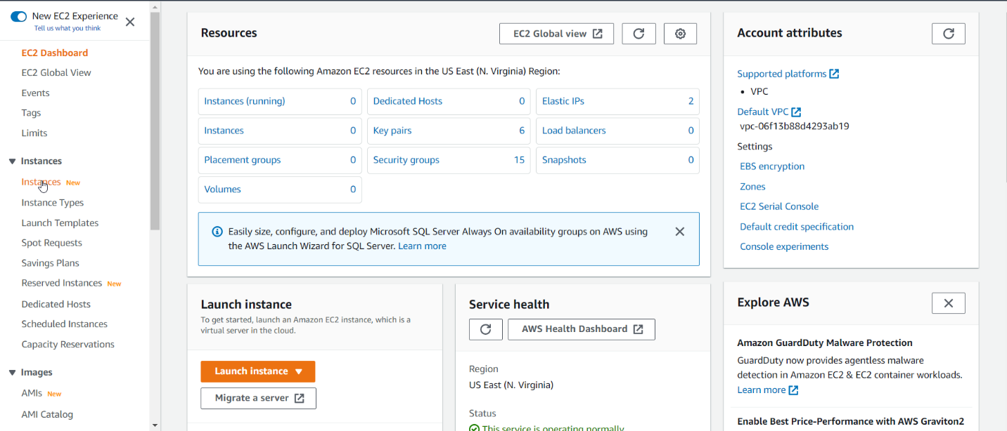

CLICK LAUNCH INSTANCE

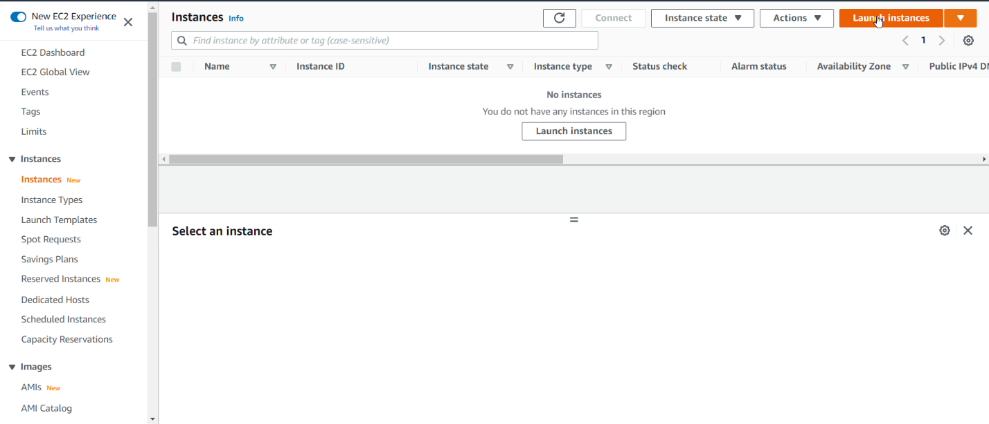

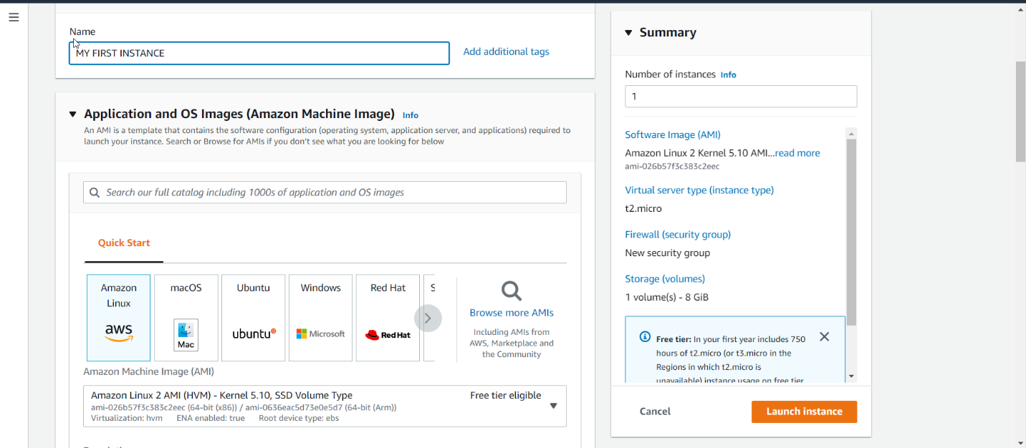

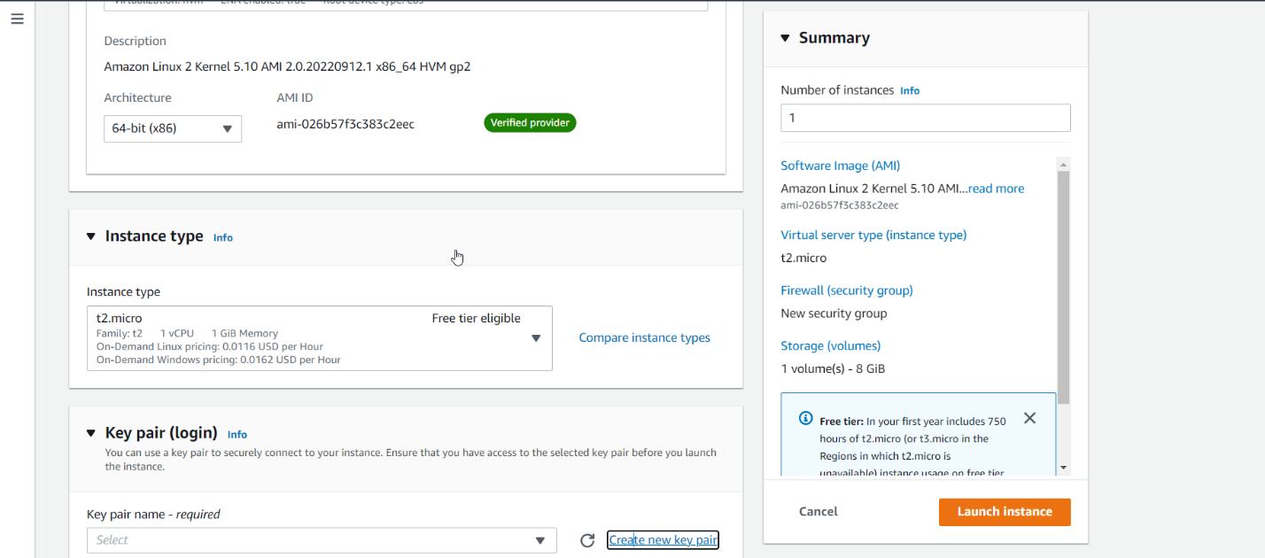

CLICK ON NEW KEY PAIR

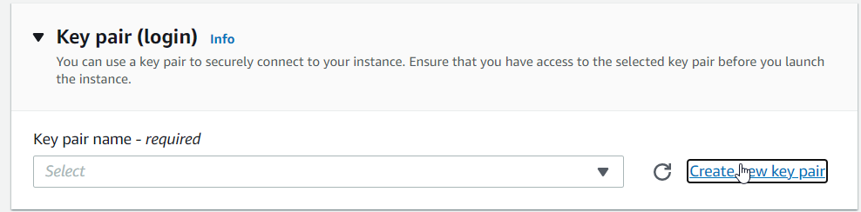

CLICK ON CREATE KEY PAIR

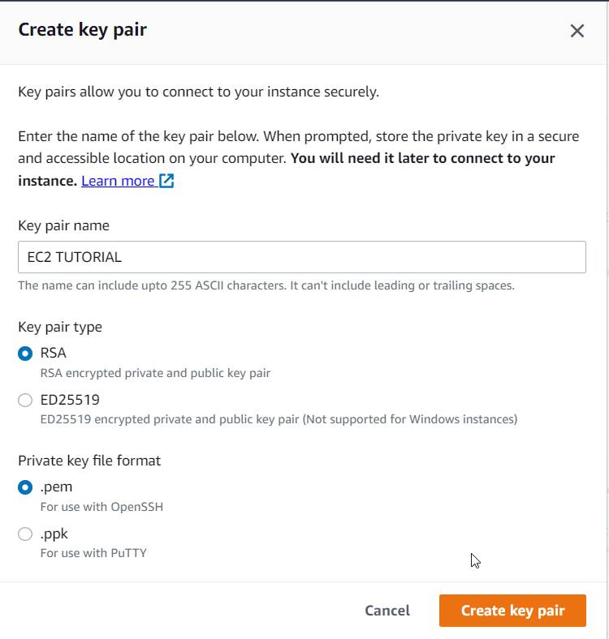

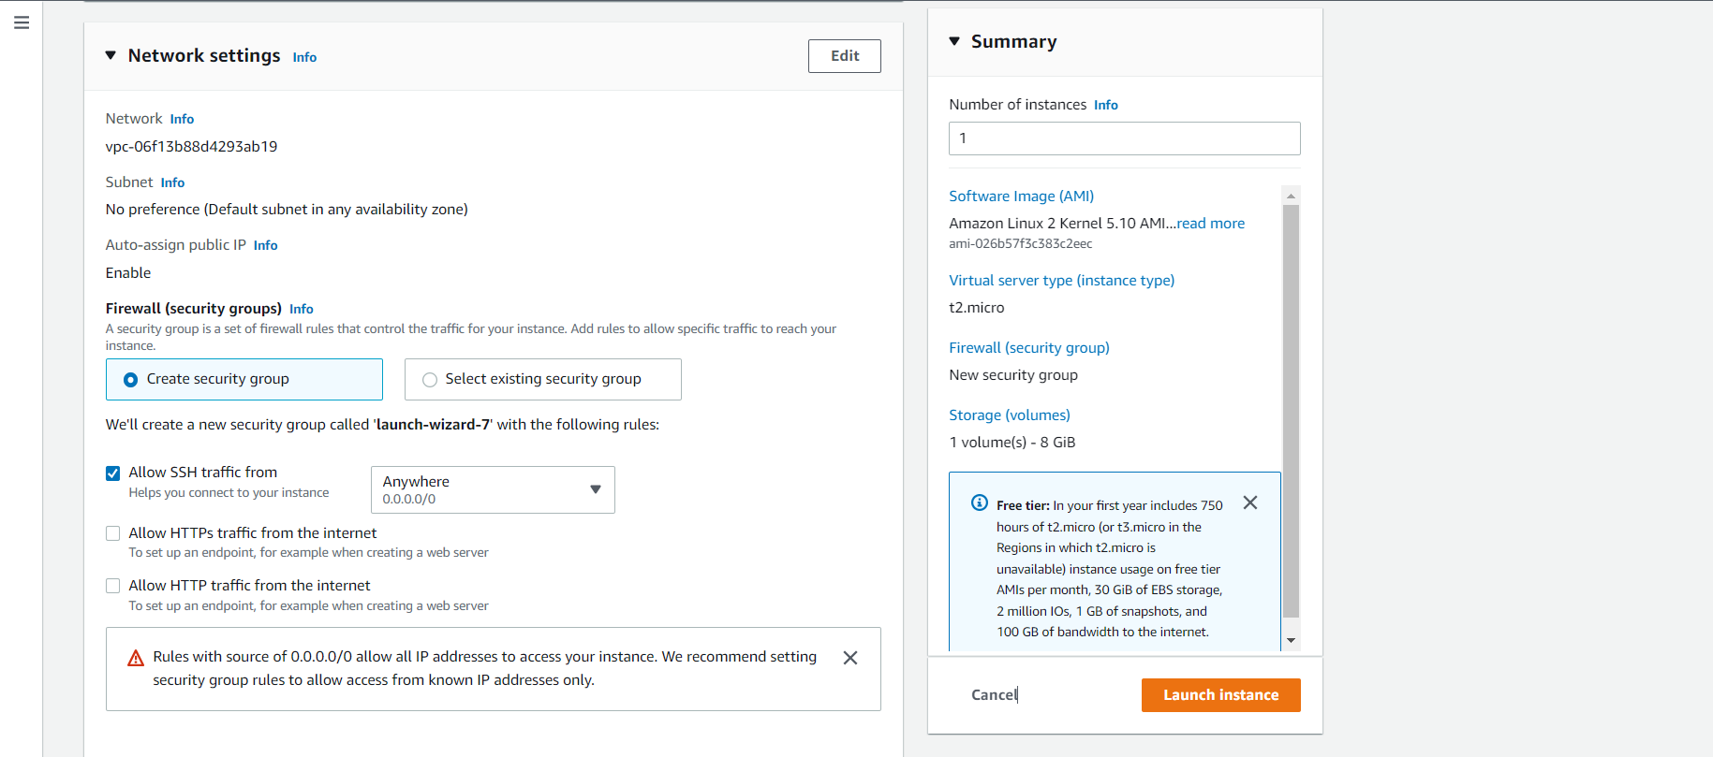

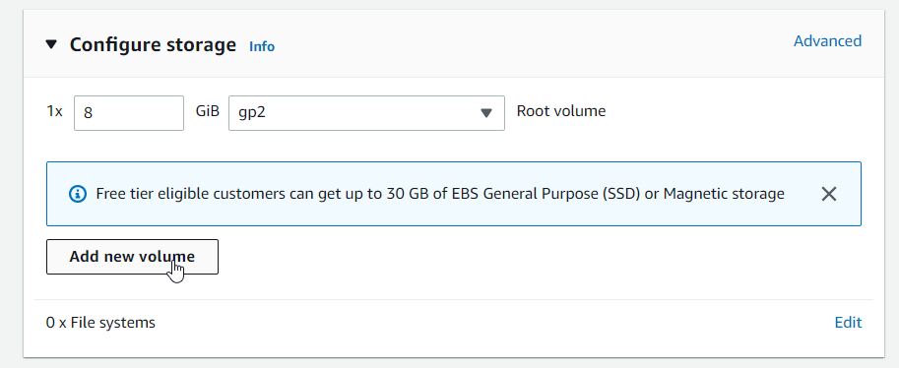

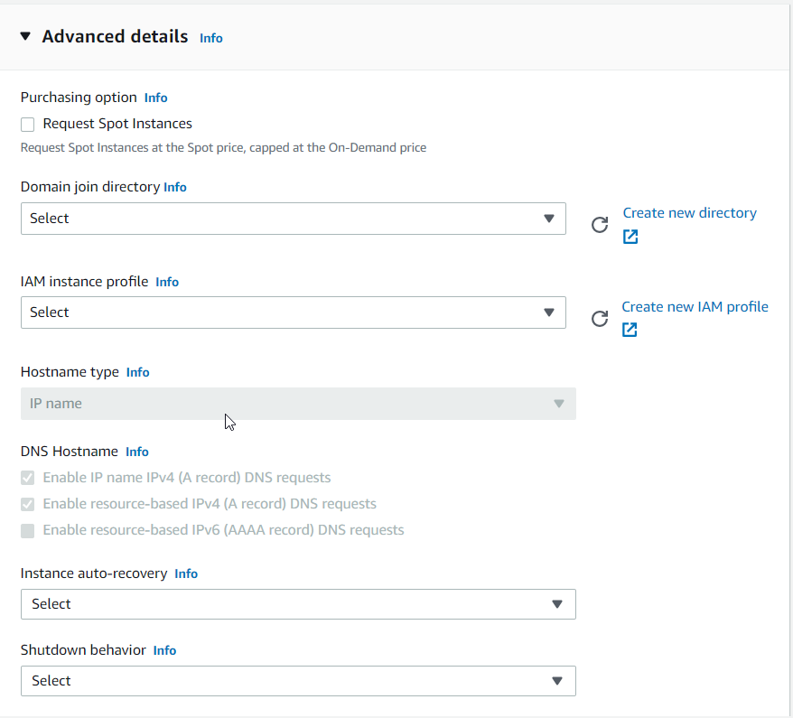

SKIP ALL ON ADVANCE DETAIL

#!/bin/bash

# Use this for your user data (script from top to bottom)

# install httpd (Linux 2 version)

yum update -y

yum install -y httpd

systemctl start httpd

systemctl enable httpd

echo "<h1>Hello World from $(hostname -f)</h1>" > /var/www/html/index.html

Go to user data

Add the following code(if your using ec2 first time)

